# Game Design Document Outline

1. Title Page
   1. Game Name – Perhaps also add a subtitle or high concept sentence.

Bell Blaster: a first-person sound puzzler.

1. Game Overview
   1. Game Concept

Player’s use their trumpet-gun to interact with a musical environment. The titular Bell is often the centerpiece to these interactions.

Players must use sound clues to find the Bell, and discover how the Bell affects the environment. Through this the player will be able to navigate levels and collect the notes scattered around each stage.

* 1. Genre

Puzzle

* 1. Target Audience

Fans of puzzles and music.

* 1. Game Flow Summary – How does the player move through the game. Both through framing interface and the game itself.

The game is first-person, with the ability to look all around the player. WASD will move the avatar, and the left-mouse button will fire the trumpet-gun.

* 1. Look and Feel – What is the basic look and feel of the game? What is the visual style?

The visual style is simple and academic. The puzzle rooms are marked with clean lines, and bold primary colours. We believe this simple style will best emphasize the sounds of the environment. Certain musical notes correspond to certain colours, like a child’s toy xylophone, imprinting a subconscious idea on the minds of the player.

1. Gameplay and Mechanics
   1. Gameplay
      1. Game Progression

The game begins in a simple hub area. From here the player will be able to look at instructions to a puzzle room, and walk through a door that loads the puzzle scene.

* + 1. Mission/challenge Structure

In some puzzle rooms the player will be able to go at their own pace, and solve the area at their leisure. Other areas will be more action based, with players tasked with finding the bell and shooting it within a certain amount of time. Players will be notified of what the challenge is before they begin the room.

Additional collectables in the form of music notes (not to be confused with the literal notes of the in-game sounds) will be scattered throughout the level, offering additional incentive for players to explore, and solve side puzzles.

* + 1. Puzzle Structure

See 5.1-levels.

* + 1. Objectives – What are the objectives of the game?

Collect as many notes as you can, while traversing through the levels.

* + 1. Play Flow – How does the game flow for the game player

The player has the option of what level they would like to play at any given time. The player is free to go at their own pace, and solve puzzles in any order they would like.

* 1. Mechanics – What are the rules to the game, both implicit and explicit. This is the model of the universe that the game works under. Think of it as a simulation of a world, how do all the pieces interact? This actually can be a very large section.

.

See 5.1 levels

* + 1. Physics – How does the physical universe work?

Gravity is active for the player, but most other objects float in the air, to be more visible and tantalizing to the player.

* + 1. Actions, including whatever switches and buttons are used, interacting with objects, and what means of communication are used

The different sides of the Bell are the primary switch used, and is activated by shooting it with the trumpet-gun (simple raycast code). Any secondary switches found around the level will also be activated with the trumpet-gun.

* + 1. Combat – If there is combat or even conflict, how is this specifically modeled?

The game is not combat based, but one area does involve finding the bell in a given amount of time and shooting it.

* + 1. Screen Flow -- A graphical description of how each screen is related to every other and a description of the purpose of each screen.

The game begins on a start screen. Afterwards, the player is thrust onto the hub world scene, at which point they can peruse the puzzle areas the game provides and decide which one they would like to play.

* 1. Game Options – What are the options and how do they affect game play and mechanics?

Time attack mode for speedrunning.

Basic mode is for exploration.

* 1. Replaying and Saving

Collectibles and time attack score are saved, and offer incentive to replay.

* 1. Cheats and Easter Eggs

1. Story, Setting and Character
   1. Story and Narrative – Includes back story, plot elements, game progression, and cut scenes. Cut scenes descriptions include the actors, the setting, and the storyboard or script.

Voiced descriptions of the puzzle create the bulk of the narrative. They are mainly expository in nature.

* 1. Game World
     1. Areas, including the general description and physical characteristics as well as how it relates to the rest of the world (what levels use it, how it connects to other areas)

1. Levels
   1. Levels. Each level should include a synopsis, the required introductory material (and how it is provided), the objectives, and the details of what happens in the level. Depending on the game, this may include the physical description of the map, the critical path that the player needs to take, and what encounters are important or incidental.

Level A:

This level is a very puzzle-based area. The Bell appears stationary in the centre of the environment, and the central conceit of the level is that the player must find ways to navigate the level, in order to shoot the bell from different angles, thus producing different effects. Long corridors and windows looking out at the bell are characteristic of this level, and the player is pushed through different areas, trying to find the right combination of notes to provide access to the collectibles and the exit.

Level B:

The level starts with a maze kind of environment where the player is supposed to collect as many notes as he/she can and shoot down the bell to traverse to the next level. Also, depending on which note it shoots down the bell on will affect the level player will advance to. This functionality helps the player to go back and forth between the levels while collecting notes. The traversing between levels also depends on the mode being played.

Level C:

The level will be a maze where the player must navigate through while collecting the musical notes. If the player gets to a dead end, there will be a deep sounding note that the player can shoot. The deep sound will indicate that they are at a dead end. Six more notes will be scattered throughout the maze. The player must shoot all seven notes to open the door to reach the end of the maze.

* 1. Training Level

The hub will introduce the player to the broad concepts of the game, such as shooting the bell to interact with the environment. (See Figure 1)

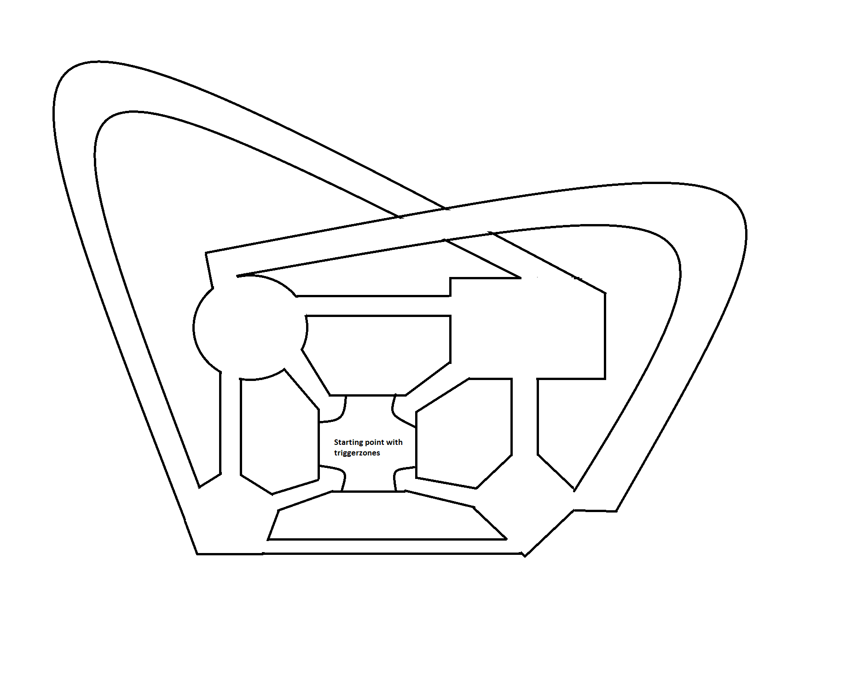

Figure 1: Taining Level

1. Interface
   1. Visual System. If you have a HUD, what is on it? What menus are you displaying? What is the camera model?

The HUD will briefly appear when the player begins a level or collects a collectible to indicate what needs to be done, and how much of it has already been completed. A timer will appear during time based levels, and always be on screen during time attack mode.

* 1. Help System

Hub level introduces concepts and controls to the player.

1. **Audio, music, sound effects** **–** **For this project, this the most important part. Sound should be a central part of the game, a driving force for everything else. Whether its cues for players to better understand what is happening in the game, or sound cues to help a player navigate the scene or avoid enemies, or special effects, or simply to enhance the game and make it more entertaining and fun. Here are some functions of sound in a game to think about as you design your game:**
   1. **Setting the mood**
   2. **Adding realism**
   3. **Providing clues to the surrounding**
   4. **Enhancing entertainment value**
   5. **Creating tactile and interface feedback**
   6. **Establishing brand identity**

7.1 Ambient BGM

The background music is meant to be melodic, but without overpowering the sounds necessary to solve puzzles. A sparse jazzy soundtrack will be used in the puzzle-oriented levels.

7.2 Providing clues to the surrounding

Areas of the environment will play a note. This note indicates that the area can be changed by interacting with the bell, and also tell the player what note they need to hit on the bell to change that area.

7.3 Creating tactile feedback

It is important that when shooting the bell, a clear and satisfying note is played to indicate that the player has successfully shot the bell. Nearby areas of the environment that correspond to this note will resonate, giving the player a clue as to what has changed nearby. Surround sound headphones are recommended to fully experience this effect properly.

1. Artificial Intelligence
   1. Opponent and Enemy AI – The active opponent that plays against the game player and therefore requires strategic decision making
   2. Support AI -- Player and Collision Detection, Pathfinding

One of the level spawns the bell randomly in different spots for a specific amount of time and also produce sound effects with different node in different region. And the bell is to be tracked and shot down by the player which also uses the functionality of collision detection.

1. Technical
   1. Target Hardware

The target hardware is any basic computer. A phone version is possible, but not a priority, as there is little guarantee that phone users would play with the sound on as intended.

* 1. Development hardware and software, including Game Engine

The game is being developed in Unity, with key assets being developed in GIMP, Blender, and Autodesk 3ds Max.

1. Game Art – Key assets, how they are being developed. Intended style.

Key assets such as the Bell, trumpet gun, and the collectables are being developed by team members using GIMP, Blender, and Autodesk 3ds Max.

They will be simplistic as the focus is having a clean puzzler with an emphasis on sound. Unnecessary details may confuse the player.

**Bell:**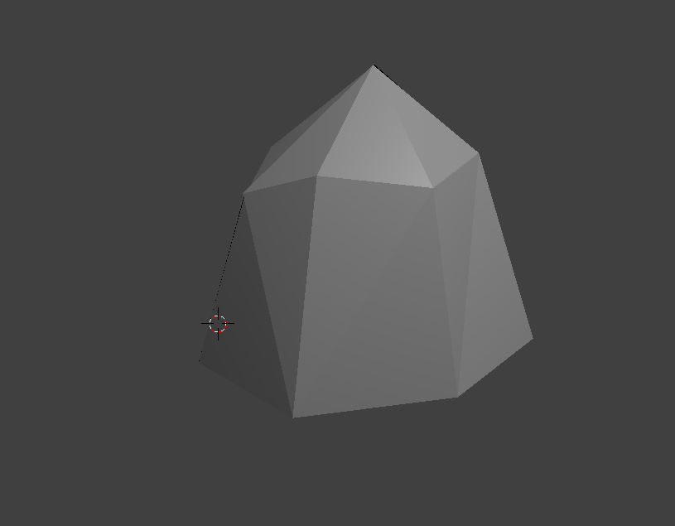

Figure 2: Bell

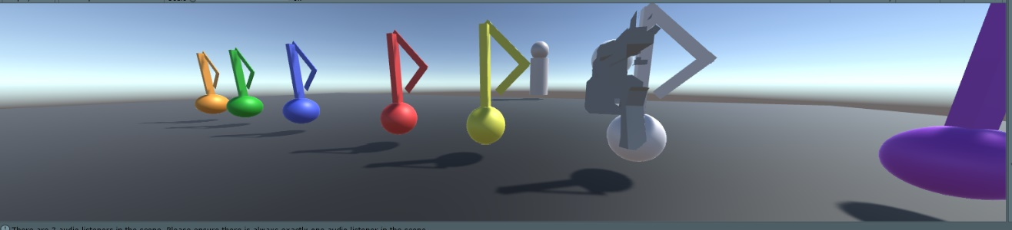

Figure 3: Music Note Collectibles